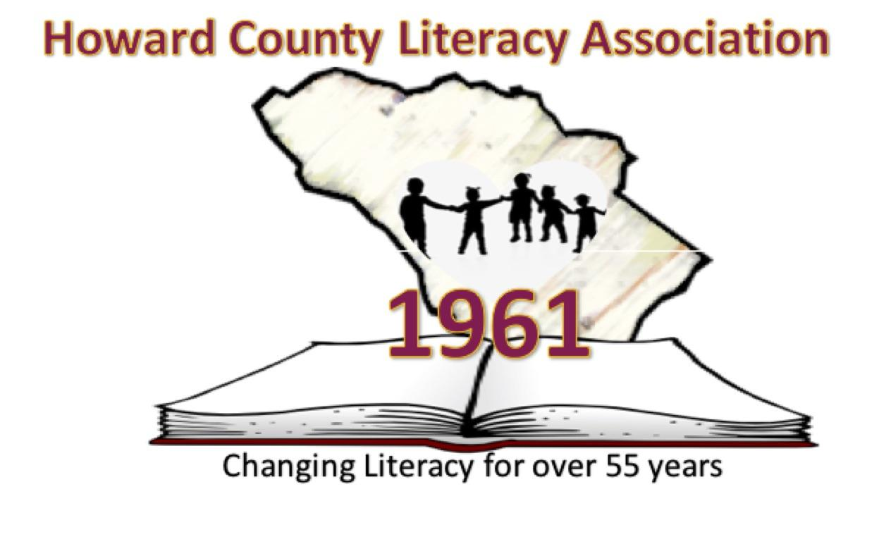
Young Authors’ Contest
Swansfield Elementary School
2021 - 2022
Who: Students in Grades 1 - 5
What: Write a poem or short story

- Each entry must be original work written within the last year by a single author. Each entry may not have been previously submitted to this contest.
- Peers or adults may provide editing assistance (spelling, punctuation, etc.), but revisions should be student-generated, and the final product must be the student’s own work.
- All entries must use no less than 12-point font in Times New Roman. All entries must be emailed as a Microsoft Word Document.
- Short story entry must range between 100-400 words (gr. 1-2) and 300-800 words (gr. 3-5).
- Poem entry will consist of a single poem, any style, and must range between 25-150 words.
- ​​Students may submit to both categories of poetry and short story, if desired.
- Entries must not include graphics.
- All entries must include a completed cover sheet signed by the parent and submitted as a separate PDF file. Parental verification may also be confirmed via a digital signature.
- Entries avoid bias against any group of people and should include school-appropriate topics.
DEADLINE:
ALL ENTRIES MUST BE SUBMITTED VIA EMAIL TO YOUR SCHOOL’S CHAIRPERSON
Ms. Greenwood at keynora_greenwood@hcpss.org
BY JANUARY 24, 2022

ONE winner PER category PER school will advance to county-level judging.

BEST OF LUCK!

